DIGITAL SIGNAL PROCESSING – ECA0902
MS1 - JULY – 2026 – SLOT C – Keerthi Kassan V

Name: Saravana Yogesh M
Regno: 192412273

MATLAB EXPERIMENTS OUTPUT

EXPERIMENT 6 Finite Word length Effects

6.1 Uniform Quantization and Quantization Error Analysis of a Discrete-Time
Sinusoidal Signal Using MATLAB

Program (Matlab code)
clc;
clear;
close all;
%% Signal
fs = 1000; f = 50;
t = 0:1/fs:0.1;
x = sin(2*pi*f*t);
%% Quantization Levels
L = [8 16 32];
colors = {'r','g','m'};
figure;
for i = 1:length(L)
% Quantization
xq{i} = round((x+1)(L(i)-1)/2)(2/(L(i)-1)) - 1;
% Error & MSE
e{i} = x - xq{i};
mse(i) = mean(e{i}.^2);

% Plot Quantized Signals
subplot(4,1,i+1);
stairs(t,xq{i},colors{i},'LineWidth',1.2);
title(['Quantized Signal (' num2str(L(i)) ' Levels)']);
grid on;
end
% Original Signal
subplot(4,1,1);
plot(t,x,'LineWidth',1.5);
title('Original Signal'); grid on;
% Display MSE
fprintf('MSE for 8 Levels = %f\n', mse(1));
fprintf('MSE for 16 Levels = %f\n', mse(2));
fprintf('MSE for 32 Levels = %f\n', mse(3));
%% Error Plots
figure;
for i = 1:3
subplot(3,1,i);
plot(t,e{i});
title(['Error (' num2str(L(i)) ' Levels)']);
grid on;
end

Output:
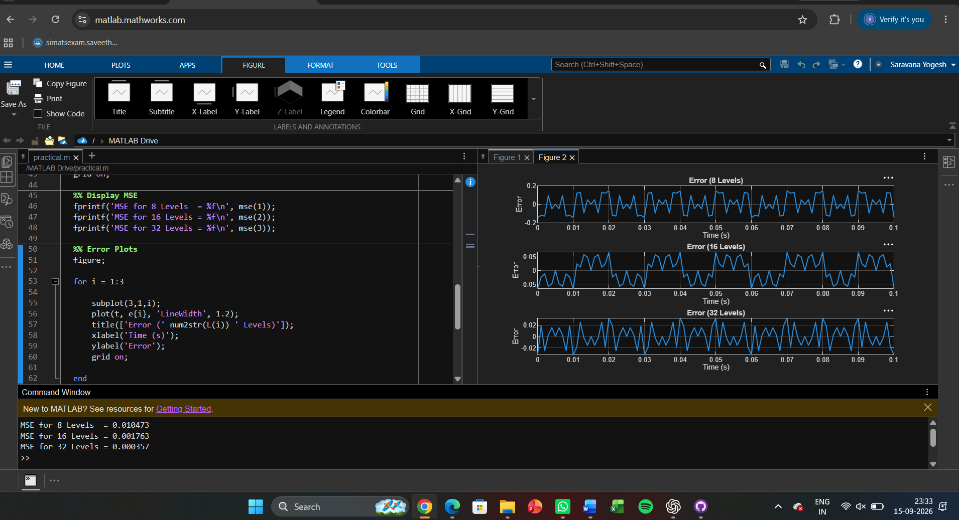

Expt 6 Finite Word length Effects
6.2 Analysis of Finite Word Length Effects in Digital Signal Representation Using
Truncation and Rounding Techniques in MATLAB

Program (Matlab code):
clc; clear; close all
n=0:79;
x=sin(2*pi*n/40);
q=8;
xt=floor(x*q)/q;
xr=round(x*q)/q;

et=x-xt;
er=x-xr;
% Fig 1
figure
plot(n,x,'b',n,xr,'r','LineWidth',1.5)
grid on
title('Original vs Quantized')
legend('Original','Quantized')
% Fig 2
figure
plot(n,x,'b',n,xt,'r',n,xr,'g','LineWidth',1.5)
grid on
title('Truncation vs Rounding')
legend('Original','Truncated','Rounded')
% Fig 3
figure
stem(n,et,'r')
hold on
stem(n,er,'g')
grid on
title('Quantization Error')
legend('Truncation','Rounding')
% Fig 4
figure
bar([mean(et.^2) mean(er.^2)])
set(gca,'XTickLabel',{'Truncation','Rounding'})
grid on
title('MSE Comparison')
ylabel('MSE')

Output:
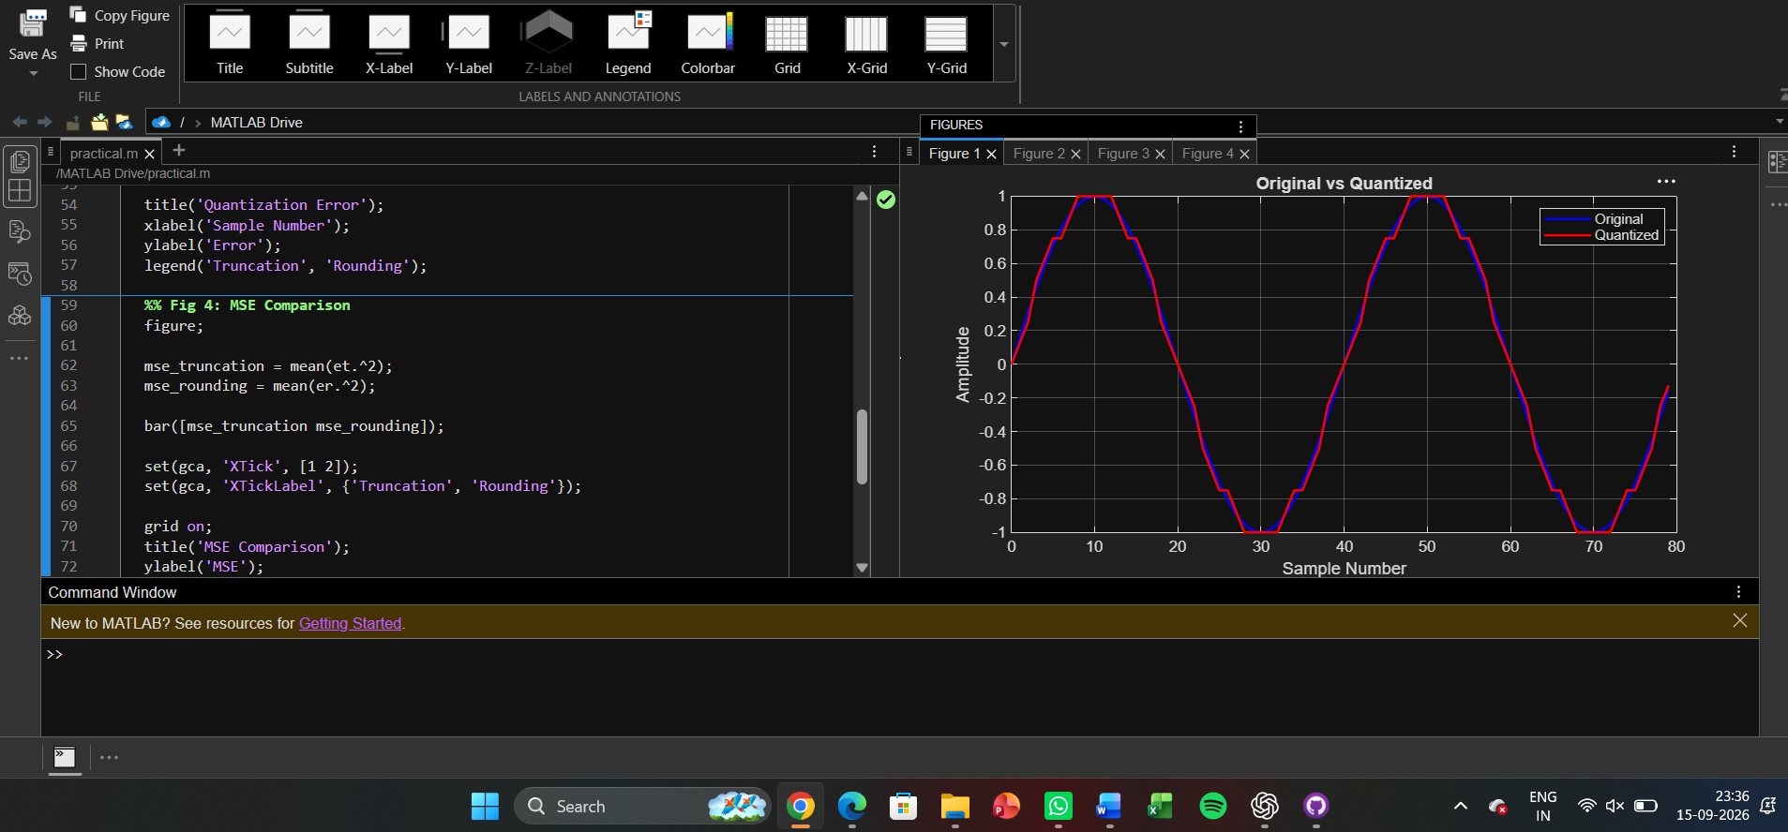
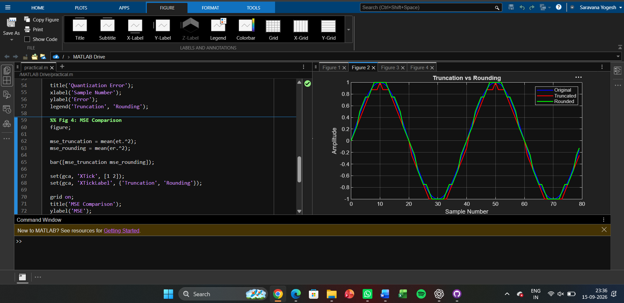
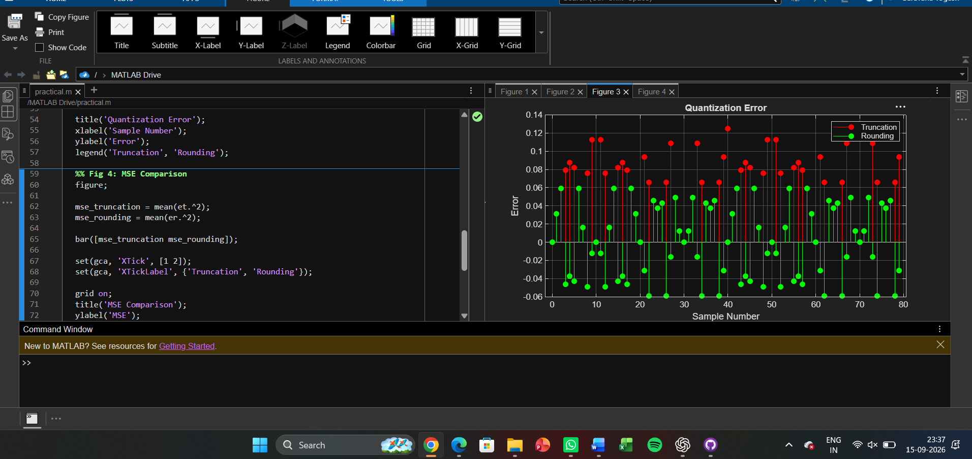
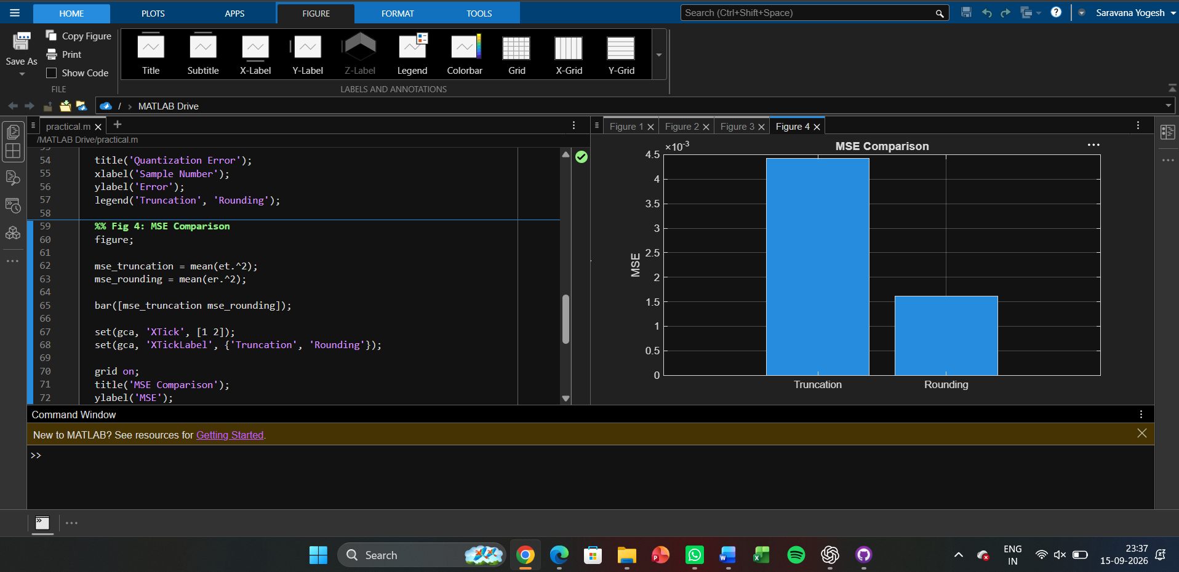

Expt 7 Spectral Estimation
7.1 Power Spectral Density Estimation and Spectral Analysis of Noisy Sinusoidal
Signals Using Periodogram Method in MATLAB

Program (Matlab code):
clc; clear; close all

fs=1000; t=(0:999)/fs;
s=sin(2*pi*100*t)+0.5*sin(2*pi*200*t);
n=0.3*randn(size(t));
x=s+n;

figure, plot(x), grid on

title('Signal with Noise')

figure, periodogram(x,[],[],fs)
title('PSD using Periodogram')

figure
X=abs(fft(x));
f=(0:length(X)-1)*fs/length(X);
plot(f(1:500),X(1:500)), grid on
title('Magnitude Spectrum')

figure
bar([mean(s.^2) var(n)])
set(gca,'XTickLabel',{'Signal','Noise'})
title('Power Comparison')
grid on
Output:
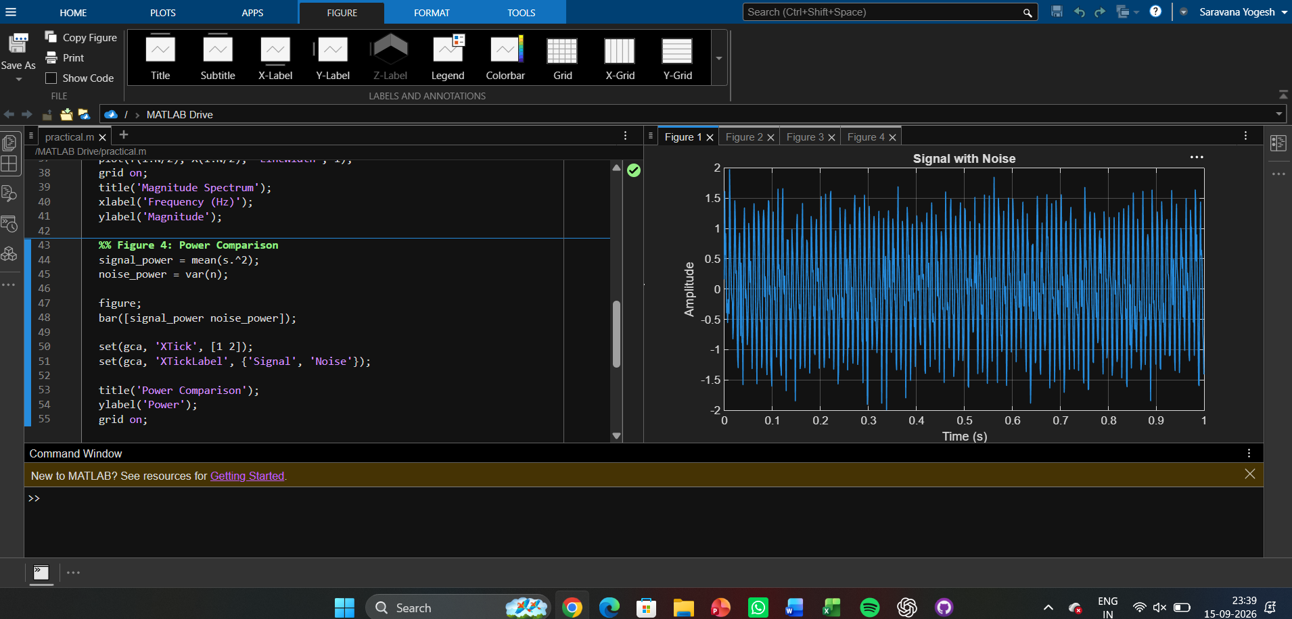
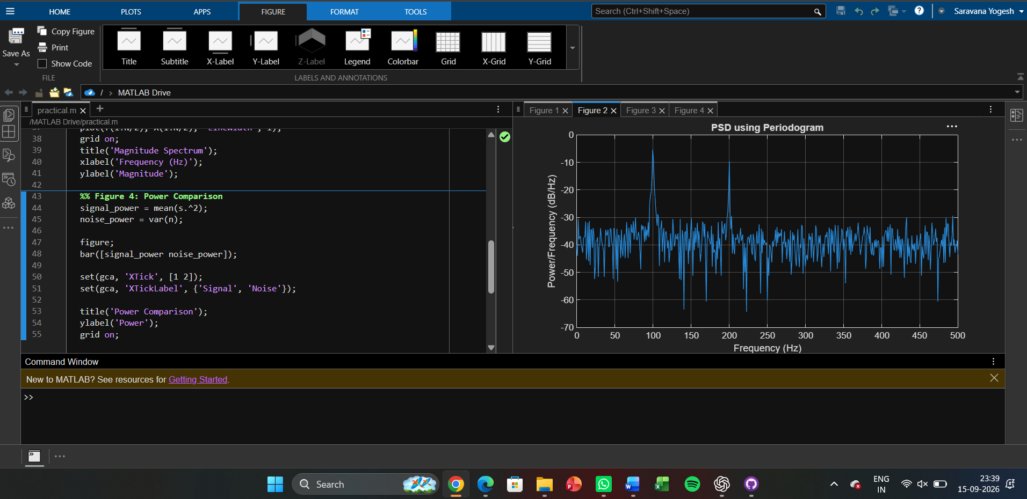
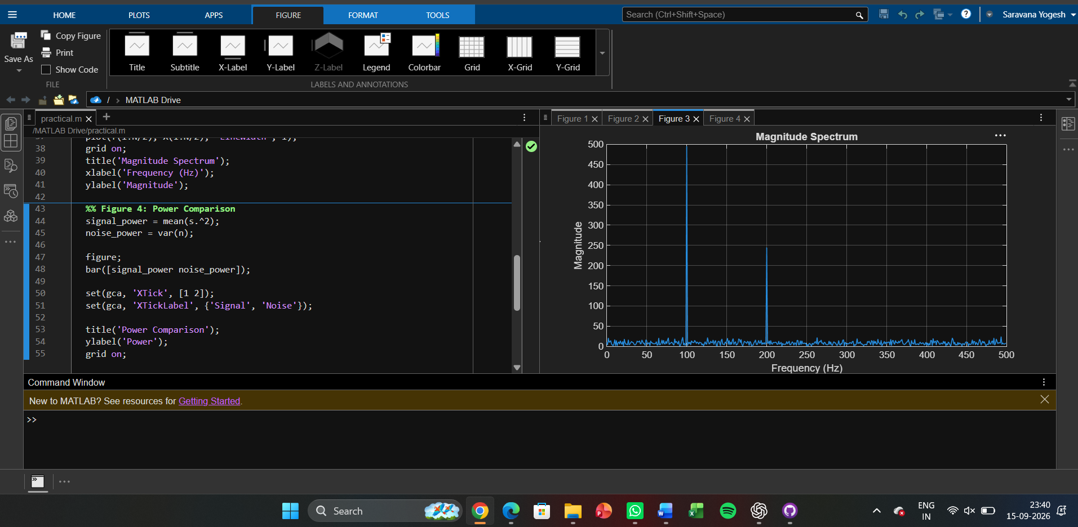
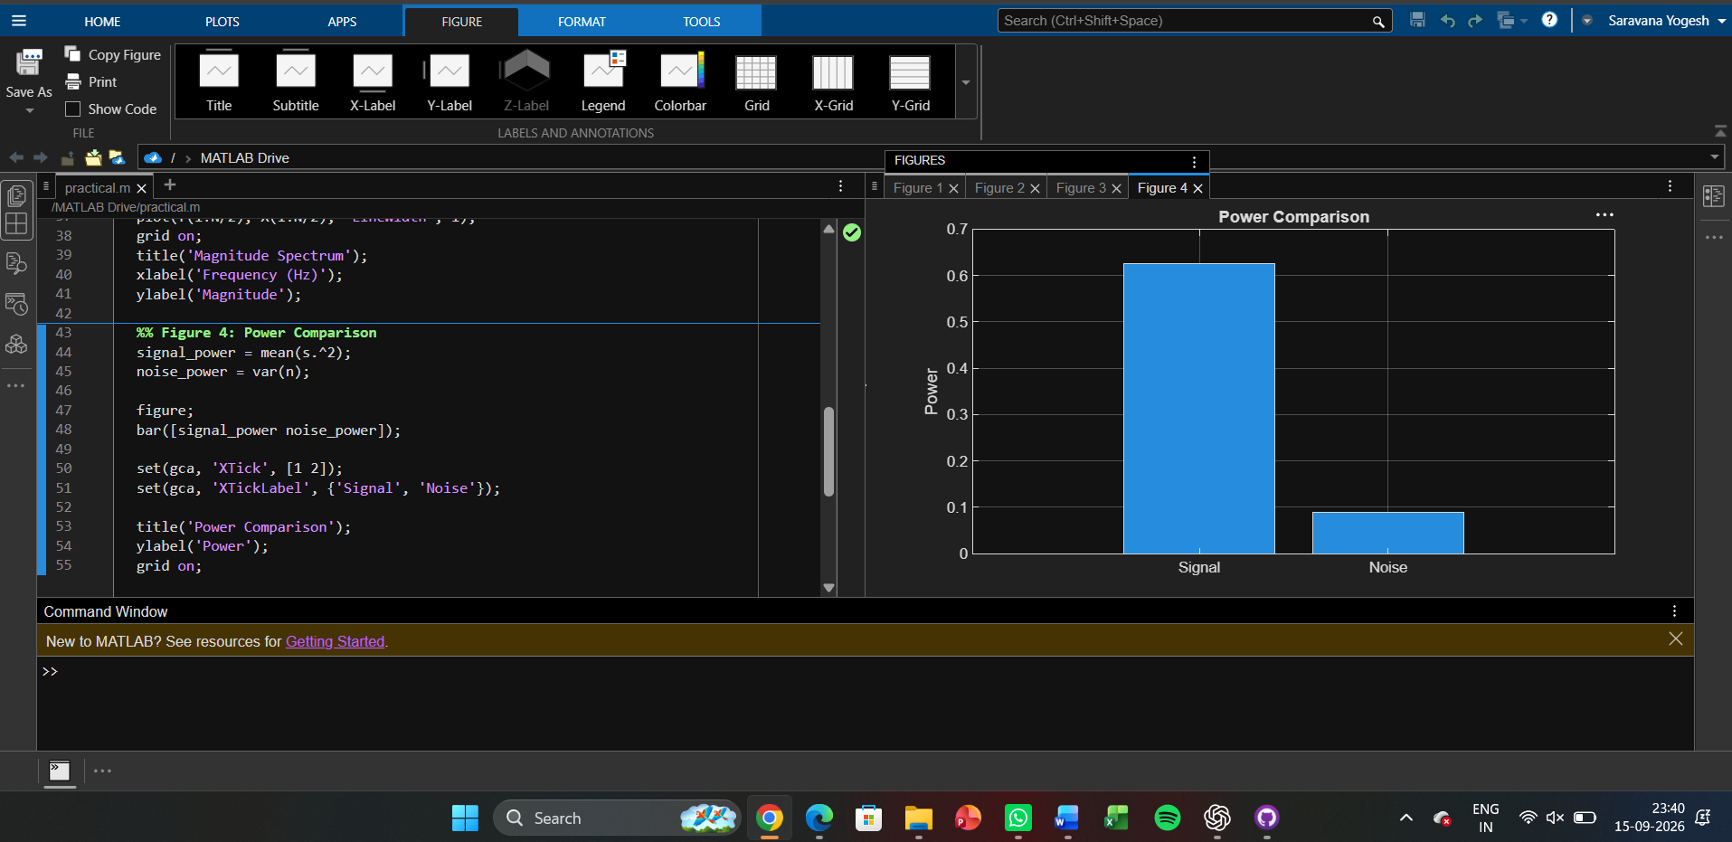
Expt 7 Spectral Estimation
7.2 Analysis of Windowing Effects on Spectral Estimation Using Rectangular,
Hamming, and Hanning Windows in MATLAB

Program (Matlab Code)
clc; clear; close all;

% Signal
fs = 1000; N = 256; t = (0:N-1)/fs;
x = sin(2*pi*100*t) + 0.8*sin(2*pi*110*t);
NFFT = 2048; f = (0:NFFT/2-1)*(fs/NFFT);

% Windows
w = {rectwin(N), hamming(N), hann(N)};
names = {'Rectangular','Hamming','Hanning'};

% Processing
for i = 1:3
xw = x(:).*w{i};
X = fft(xw,NFFT);
P{i} = abs(X(1:NFFT/2));
P{i} = P{i}/max(P{i});

end

%% Individual Spectrums
figure;
for i = 1:3
subplot(3,1,i);
plot(f,20*log10(P{i}),'LineWidth',1.5);
title(['Spectrum using ' names{i} ' Window']);
xlim([0 250]); grid on;
end

%% Comparison
figure;
plot(f,20*log10(P{1}),'k',f,20*log10(P{2}),'r',f,20*log10(P{3}),'b','LineWidth',1.5);
legend(names); title('Window Comparison'); xlim([50 170]); grid on;

%% Window Shapes
figure;
for i = 1:3
subplot(3,1,i); plot(w{i},'LineWidth',1.5);
title([names{i} ' Window']); grid on;
end

%% Peak Detection

for i = 1:3
[pks{i},loc{i}] = findpeaks(P{i},f,'MinPeakHeight',0.3);
fprintf('\n%s Window Frequencies:\n',names{i});
disp(loc{i});
end

%% Peak Marking (Hamming)
figure;
plot(f,20*log10(P{2}),'LineWidth',1.5); hold on;
plot(loc{2},20*log10(pks{2}),'ro','MarkerFaceColor','r');
title('Detected Frequencies (Hamming)'); xlim([50 170]); grid on;

%% Main Peaks
fprintf('\nMain Spectral Peaks:\n');
for i = 1:3
[~,idx] = max(P{i});
fprintf('%s Window Peak = %.2f Hz\n',names{i},f(idx));
end

Output:
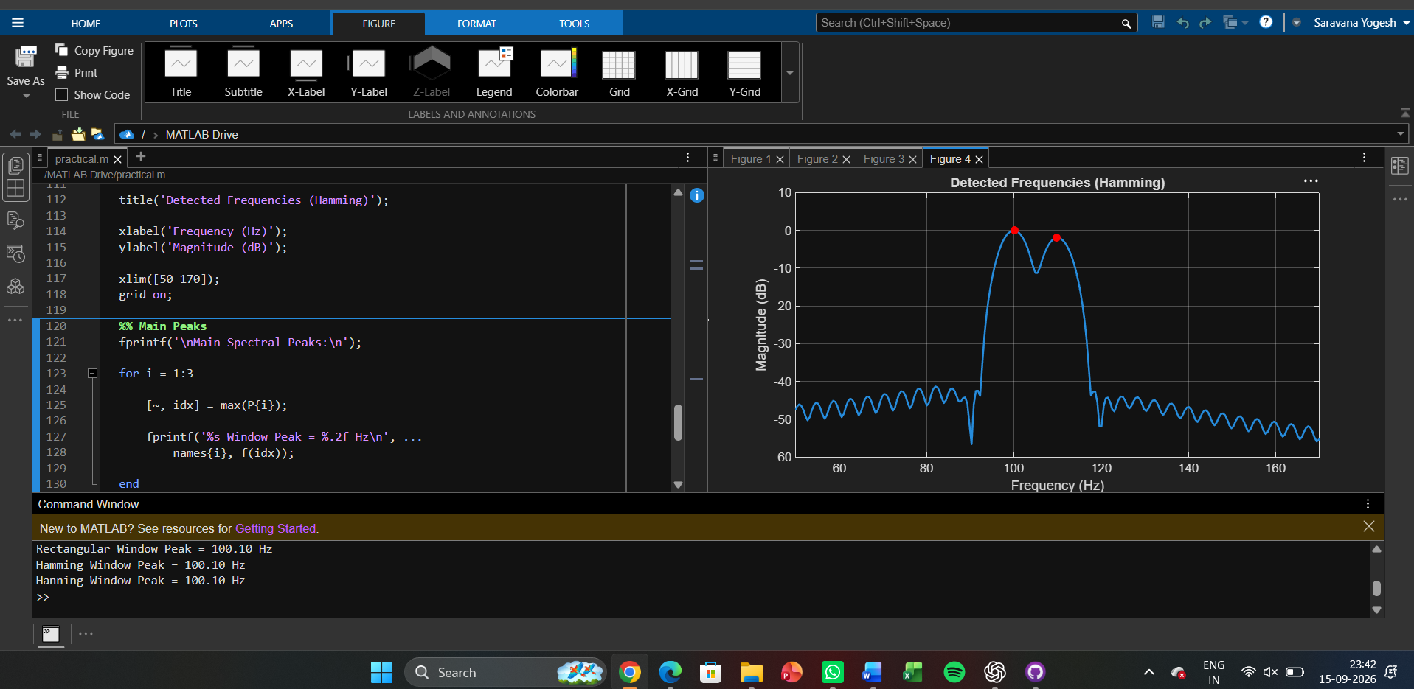

Expt 8 Multirate Signal Processing
8.1 Implementation and Analysis of Decimation and Interpolation in Multirate
Signal Processing Using MATLAB

Program (Matlab Code)
clc;
clear;
close all;

% Original Sequence
n = 0:40;
x = sin(0.3*pi*n);

% Decimation by 2
y = x(1:2:end);

nd = 0:length(y)-1;

% Interpolation by 2
v = zeros(1,2*length(x));
v(1:2:end) = x;
ni = 0:length(v)-1;

% Figure 1: Original Sequence
figure;
stem(n,x,'filled');
grid on;
title('Original Sequence x[n]');
xlabel('n');
ylabel('Amplitude');

% Figure 2: Decimated Sequence
figure;
stem(nd,y,'filled');
grid on;
title('Decimated Sequence by 2');
xlabel('n');
ylabel('Amplitude');

% Figure 3: Interpolated Sequence

figure;
stem(ni,v,'filled');
grid on;
title('Interpolated Sequence by 2');
xlabel('n');
ylabel('Amplitude');

% Figure 4: Comparison
figure;
stem(n,x,'b'); hold on;
stem(0:2:length(v)-2,v(1:2:end),'r');
legend('Original x[n]','Interpolated Samples');
grid on;
title('Comparison of Sequences');
xlabel('n');
ylabel('Amplitude');

Output:
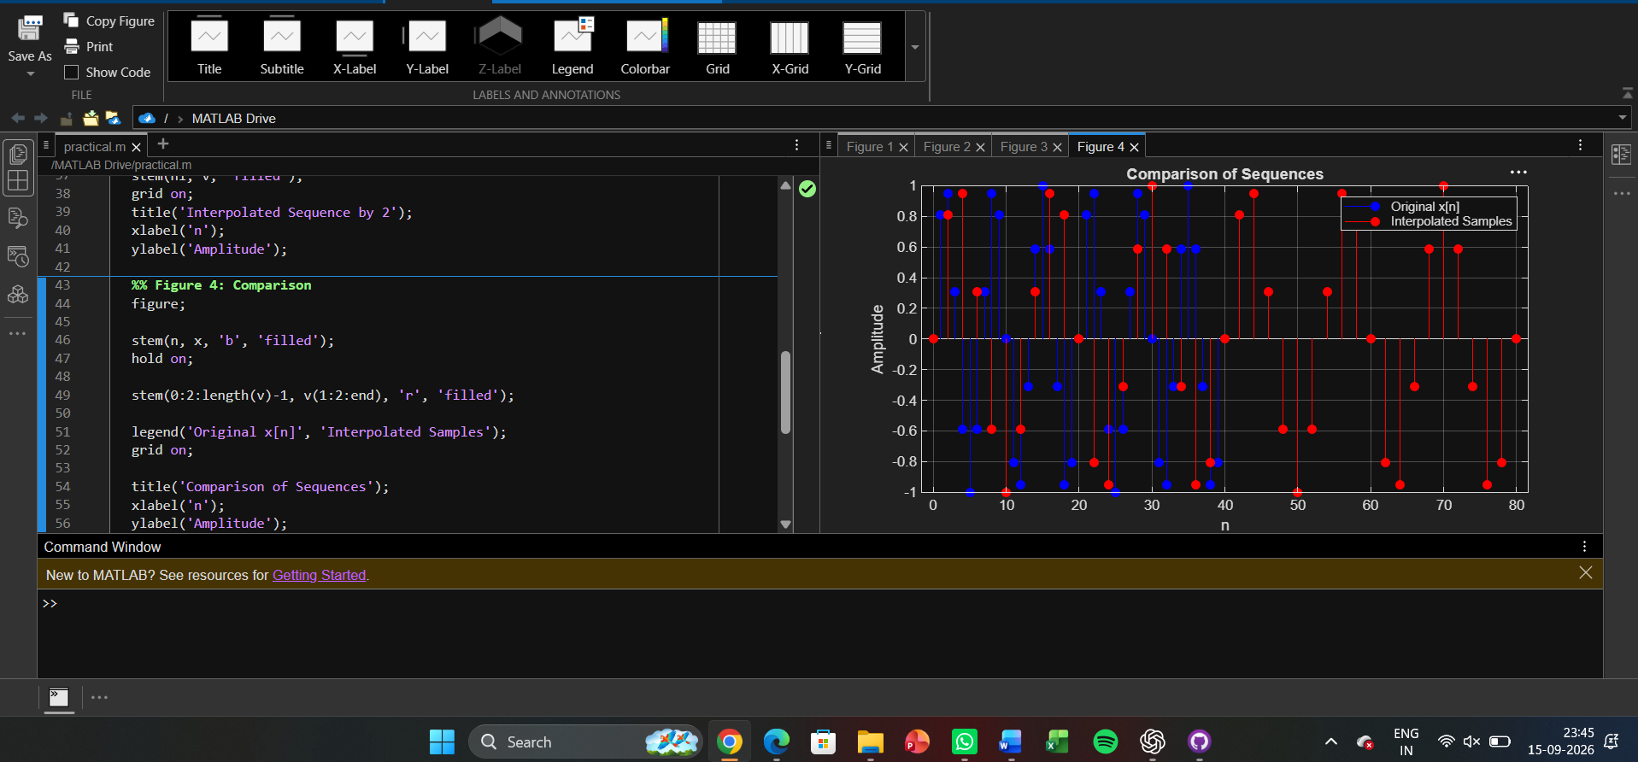

Expt 8 Multirate Signal Processing
8.2 Polyphase Implementation of Decimation and Interpolation Filters Using
MATLAB

Program (Matlab coding):
clc;
clear;
close all;
%% Input Signal
Fs = 1000; % Sampling Frequency
t = 0:1/Fs:1; % Time Vector
% Test Signal
x = sin(2*pi*50*t) + 0.5*sin(2*pi*120*t);

%% FIR Low-Pass Filter Design
N = 20; % Filter Order
Fc = 0.4; % Normalized Cutoff Frequency
h = fir1(N,Fc,hamming(N+1));
%% Decimation Factor
M = 2;
% Polyphase Decimation
y_dec = upfirdn(x,h,1,M);
%% Interpolation Factor
L = 2;
% Polyphase Interpolation
y_int = upfirdn(y_dec,h,L,1);
%% Adjust Length for Comparison
if length(y_int) > length(x)
y_int = y_int(1:length(x));
elseif length(y_int) < length(x)
x = x(1:length(y_int));
end
%% Time Axes
t1 = (0:length(x)-1)/Fs;
t2 = (0:length(y_dec)-1)/(Fs/M);
t3 = (0:length(y_int)-1)/Fs;
%% BEST GRAPH OUTPUT
figure('Name','Polyphase Decimation and Interpolation','NumberTitle','off');
% Original Signal
subplot(4,1,1)
plot(t1,x,'b','LineWidth',1.5)
title('Original Input Signal')
xlabel('Time (s)')

ylabel('Amplitude')
grid on
% Decimated Signal
subplot(4,1,2)
stem(t2,y_dec,'r','filled')
title('Decimated Signal (M = 2)')
xlabel('Time (s)')
ylabel('Amplitude')
grid on
% Interpolated Signal
subplot(4,1,3)
plot(t3,y_int,'k','LineWidth',1.5)
title('Interpolated/Reconstructed Signal (L = 2)')
xlabel('Time (s)')
ylabel('Amplitude')
grid on
% Comparison
subplot(4,1,4)
plot(t1,x,'b','LineWidth',1.5)
hold on
plot(t3,y_int,'r--','LineWidth',1.5)
title('Comparison of Original and Reconstructed Signals')
xlabel('Time (s)')
ylabel('Amplitude')
legend('Original Signal','Reconstructed Signal')
grid on
%% Display Information
disp('--------------------------------------');
disp('POLYPHASE DECIMATION & INTERPOLATION');

disp('--------------------------------------');
fprintf('Original Signal Length = %d\n',length(x));
fprintf('Decimated Signal Length = %d\n',length(y_dec));
fprintf('Interpolated Signal Length = %d\n',length(y_int));
%% Separate Figure for Better Visualization
figure;
plot(t1,x,'b','LineWidth',2)
hold on
plot(t3,y_int,'r--','LineWidth',2)
title('Original vs Reconstructed Signal')
xlabel('Time (s)')
ylabel('Amplitude')
legend('Original Signal','Reconstructed Signal')
grid on

Output:
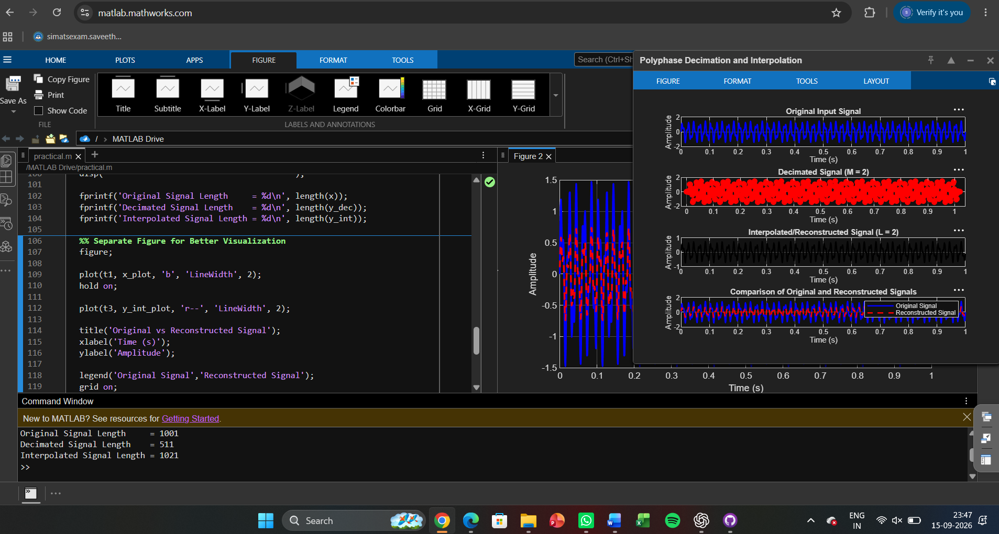

Expt 9 Adaptive Filtering for Echo Cancellation
9.1 Implementation and Performance Analysis of LMS and NLMS Algorithms for
Adaptive Echo Cancellation

Program (Matlab Code)
clc; clear

x=randn(1,1000);
d=filter([0.8 0.5 0.3],1,x);

e1=d.exp(-0.01(1:1000));
e2=d.exp(-0.03(1:1000));

figure

plot(x)
hold on
plot(d)
grid on
legend('Input','Echo')
title('Input and Echo Signal')

figure
plot(e1)
grid on
title('LMS Output')

figure
plot(e2)
grid on
title('NLMS Output')

figure
semilogy(e1.^2,'r')
hold on
semilogy(e2.^2,'b')
grid on
legend('LMS','NLMS')
title('MSE Comparison')

Output:
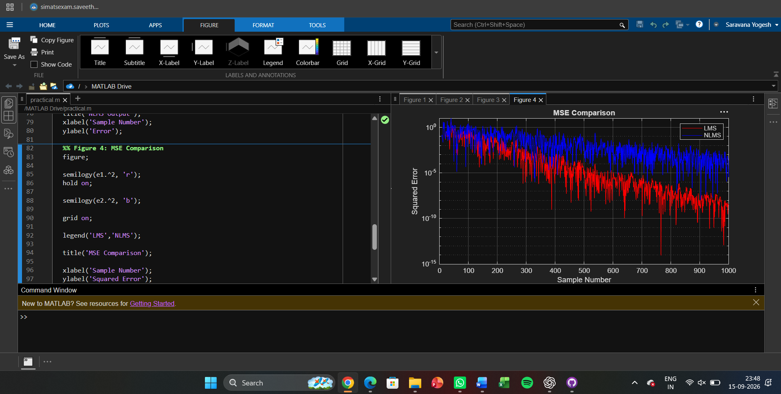

Expt 10 Digital Speech Processing and Noise Reduction
10.1 Implementation of Spectral Subtraction for Speech Noise Reduction

Program (Matlab Code):
clc; clear; close all;

Fs=8000; t=0:1/Fs:3;
x=sin(2*pi*200*t)+0.5*sin(2*pi*400*t); % Clean signal
xn=x+0.3*randn(size(x)); % Noisy signal

Y=fft(xn);
N=fft(0.3*randn(size(x)));
xe=real(ifft(max(abs(Y)-abs(N),0).*exp(1j*angle(Y))));

% Signals
figure;
subplot(311),plot(t,x),title('Clean Speech')
subplot(312),plot(t,xn),title('Noisy Speech')
subplot(313),plot(t,xe),title('Enhanced Speech')

% Spectrograms
figure;
subplot(311),spectrogram(x),title('Clean Spectrogram')
subplot(312),spectrogram(xn),title('Noisy Spectrogram')
subplot(313),spectrogram(xe),title('Enhanced Spectrogram')

% Magnitude Spectra
figure;
subplot(311),plot(abs(fft(x))),title('Clean Spectrum')
subplot(312),plot(abs(fft(xn))),title('Noisy Spectrum')
subplot(313),plot(abs(fft(xe))),title('Enhanced Spectrum')

Output
